H.T No
Regulations:
A14

Sreenidhi Institute of Science and Technology
(An Autonomous Institution)
Code No: 4H315 Date: 01-Feb-2024 (FN)

B.Tech II-Year I- Semester External Examination, Jan/Feb - 20243 (Supplementary)
Engineering Mathematics-III (Common to All Except BT)

Time: 3 Hours Max.Marks:70

Note: a) No additional answer sheets will be provided.
b) All sub-parts of a question must be answered at one place only, otherwise it will not be valued.
c) Missing data can be assumed suitably.

Bloom's Cognitive Levels of Learning (BCLL)

Remember | L1 | Apply | L3 | Evaluate | L5
Understand | L2 | Analyze | L4 | Create | L6

Part - A Max.Marks:20
Answer all QUESTIONS

 |  | BCLL | CO(s) | Marks
1 | Evaluate 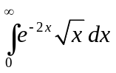, using Beta and Gamma functions. | L2 | CO1 | [2M]
2 | Find the value of such that 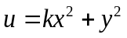 is a harmonic function. | L4 | CO2 | [2M]
3 | Define Fourier sine and cosine transformation. | L2 | CO3 | [2M]
4 | Write Newton Raphson formula for finding the reciprocal of a natural number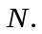 | L1 | CO4 | [2M]
5 | Define forward and backward differences. | L1 | CO5 | [2M]
6 | Find, using Euler’s method . | L3 | CO6 | [2M]
7 | Write 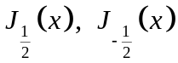in terms of 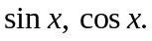 | L5 | CO1 | [2M]
8 | Evaluate 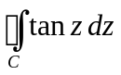 ,where at 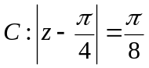 | L3 | CO2 | [2M]
9 | Write the Simpson’s 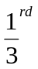rule. | L2 | CO4 | [2M]
10 | Write the predictor –corrector formulas in the Milne’s method. | L1 | CO6 | [2M]
Part – B Max.Marks:50
ANSWER ANY FIVE QUESTIONS. EACH QUESTION CARRIES 10 MARKS.

 |  |  | BCLL | CO(s) | Marks
11. | a) | Evaluate 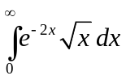, using Beta and Gamma functions | L2 | CO1 | [5M]
 | b) | Evaluate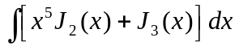 | L1 | CO1 | [5M]
12. | a) | Check whether 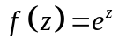, is analytic at every point in the complex plane | L3 | CO2 | [5M]
 | b) | Find all the possible Laurent’s series expansion of  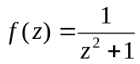 about 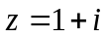 | L3 | CO2 | [5M]
13. | a) | Find the Fourier sine transform of f(x) = 2e^{-5x}+5e^{-2x} ? | L3 | CO3 | [5M]
 | b) | Find the Fourier cosine transform of 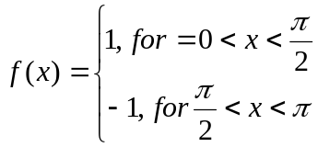 | L5 | CO3 | [5M]
14. | a) | Find an approximate positive real root of 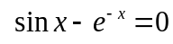, by  Newton Raphson method, correct to four decimal places | L2 | CO4 | [5M]
 | b) | Evaluate 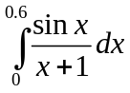 by using (i) Trapezoidal rule (ii).Simpson’s 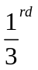rule by taking 6 number of subintervals | L3 | CO4 | [5M]
15. |  | From the following table, estimate the number of students who obtained marks between 40 and 45 | L1 | CO5 | [10M]
  Marks | 30-40 | 40-50 | 50-60 | 60-70 | 70-80
  No. of Students | 31 | 42 | 51 | 35 | 31
16. | a) | Find 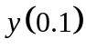 from the initial value problem 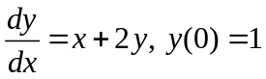 by Taylor’s series method. | L3 | CO6 | [5M]
 | b) | Find 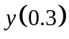 from the initial value problem 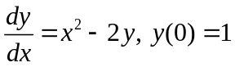 in steps of 0.1 by Runge- Kutta method of fourth order | L3 | CO6 | [5M]
17. | a) | Write the relation between beta and gamma functions. | L2 | CO1 | [3M]
 | b) | Evaluate 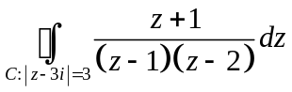 | L3 | CO2 | [4M]
 | c) | State Parseval's idenity. | L1 | CO3 | [3M]
18. | a) | Find an approximate value of 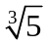 , using fixed point iteration method | L2 | CO4 | [5M]
 | b) | Find, using modified Euler’s method | L3 | CO6 | [5M]

-- 00 -- 00 –

